Name: ___________________________________________________ Date: ___________________________
Base Group:________________ Lab: _____________________

DO NOT LOSE THIS PACKET!

I can measure different properties of waves and relate it to the amount of energy a wave has.

Date | Task | Competed?
 | Property of Waves Notes
 | Measuring Wave Properties Review
Wave Worksheet
Practice #2
 | Wave Reading
 | Bill Nye: Waves!

imcscience.weebly.com

Learning Goal: I can identify the different properties of waves.

Property of Waves Notes
A wave is _____________________________________________ and _____________________________________.

Waves are ________________________________________________, but __________________________________.
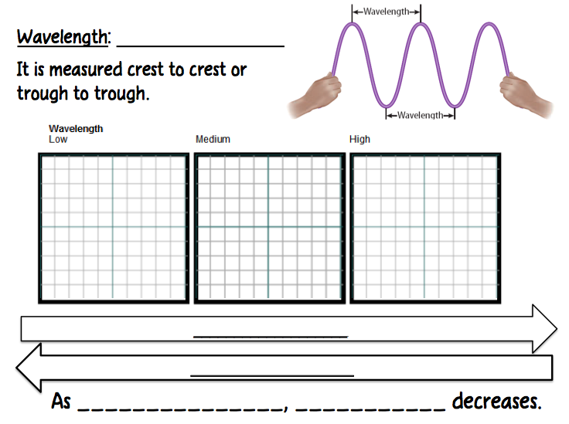
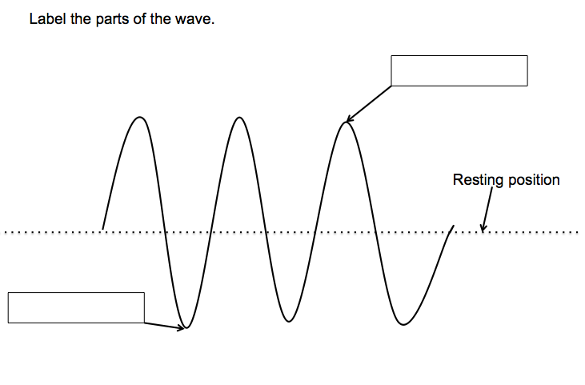

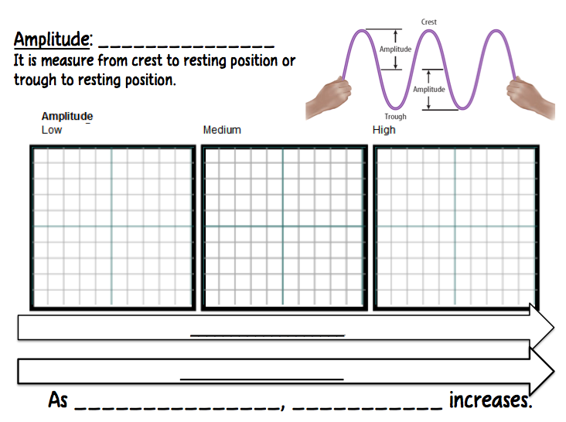

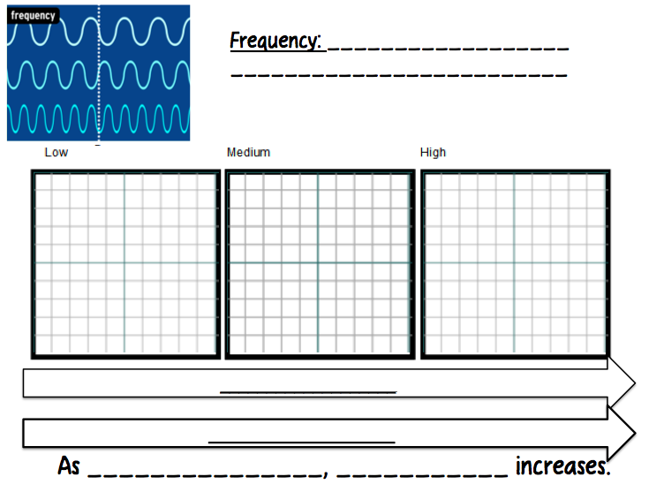

Measuring Wave Properties Review

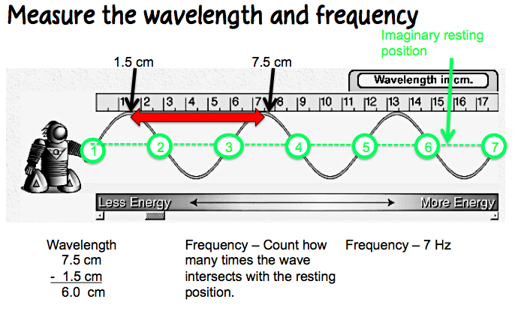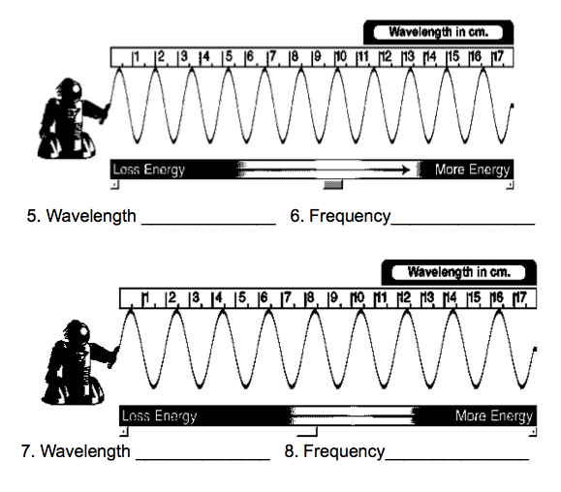
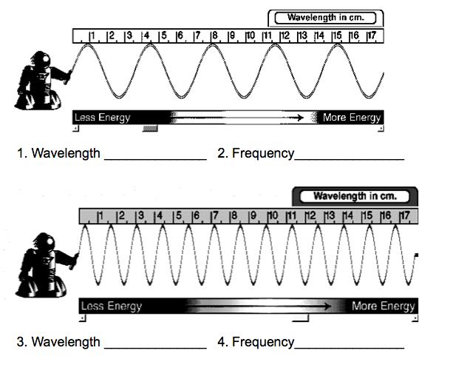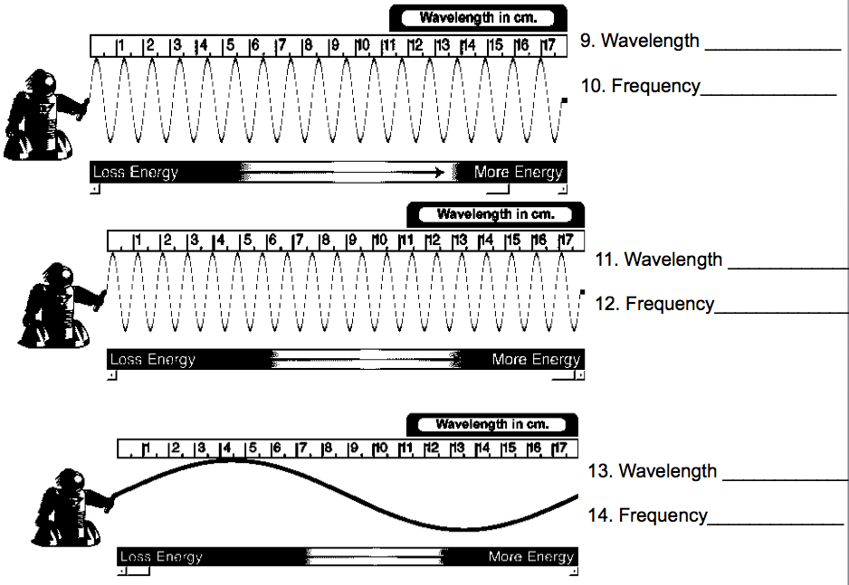

Wave Worksheet
Practice #2

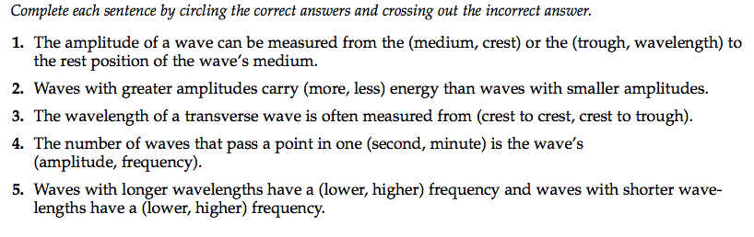
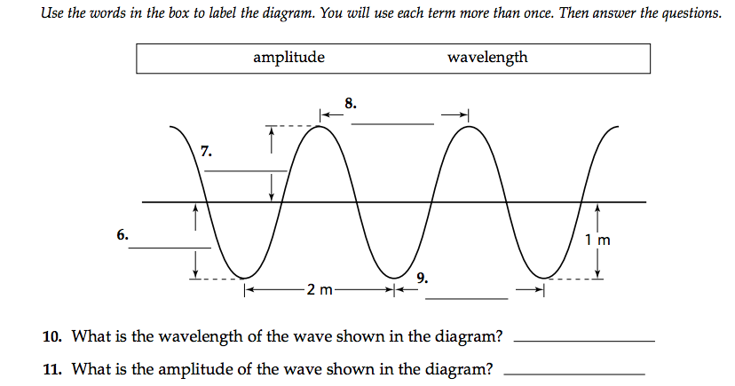

Wave Reading

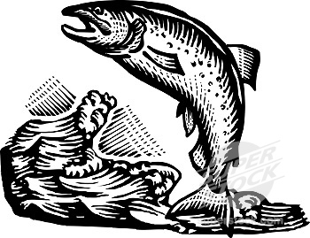
Picture yourself sitting by the shore of a lake on a beautiful day. A fish jumps out of the water and falls back in, making a splash. You notice the circles of waves that move outward from the fish’s entry point. These outward circular waves pass by a duck and cause it to bob up and down. However, the duck did not move any closer to or any farther away from you. Waves are able to transmit energy, but not matter.

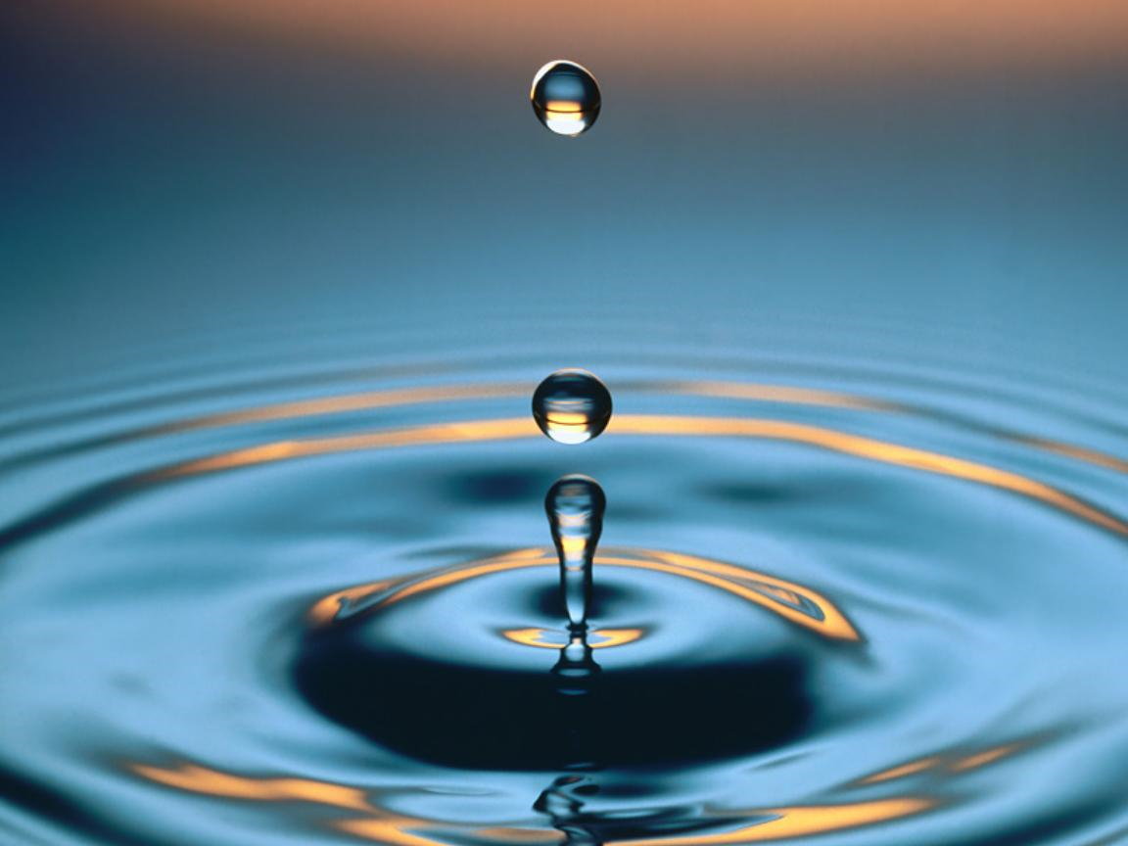
Making Waves
If a pebble is thrown into water, you can see waves moving outward from where the pebble entered the water. Energy from the pebble’s splash causes the water to move up and down. The pebble caused a disturbance in the water. This disturbance caused a wave to move through the water in the form of up-and-down motion of water molecules. A wave is caused by a disturbance and transmits energy.

The up-and-down movement of the water near the pebble was transferred to nearby water. In a wave, energy is transferred through vibrations, or back-and-forth movements. A vibrating particle transfers its energy to a nearby particle. This new particle then transfers the energy to yet another nearby particle, and so on.

The material through which waves can travel is called a medium. A medium can be a gas, a liquid, or a solid. Waves that need a medium to travel are called mechanical waves.

Water is the medium for objects and waves moving through the ocean. Air is the medium for the sound waves we hear at a band concert. An earthquake is another example of waves transferring energy. As the ground shakes up and down and from side to side, waves travel away from the source of the earthquake. The ground does not travel miles from the source; only the energy travels outward in a wave.

Properties of Waves
To understand how waves behave, picture tying one end of rope to a doorknob and holding on the other end of the rope. If you flick the rope up, vertically, you have caused a disturbance. This starts a wave that moves along the rope away from the disturbance. The wave consists of a series of crests and troughs. The highest point on a wave is the crest, and the lowest point is called a trough.

Waves can be described by several properties. Amplitude is a measurement of how high the crest of a wave rises or how low the trough dips below the resting position. The larger the amplitude, the more energy is carried, resulting in a taller wave. Another property of a wave is wavelength. The distance between any two crests that are next to each other is the wavelength. Wavelengths can also be measured between two adjacent troughs.

The number of waves produced in a given amount of times is the frequency. The word frequent means “often.” Frequency is measured by counting the number of crests or troughs that pass by a given point in one second. Think about snapping a rope back and fort to make a wave. The speed with which you snap the rope affects the frequency of the wave. The wave on the quickly snapped rope would have a higher frequency.

Snapping the rope back and forth quickly requires more energy than snapping it slowly. If the amplitudes of two waves were equal, the quickly snapped rope would have more energy than the slowly snapped rope. The unit of measurement for frequency is hertz (Hz). For waves, one hertz equals one wave per second or 1Hz = 1/s.

Frequency and wavelength are related. A wavelength with lower frequency has a longer wavelength. The opposite is also true. When frequency increases, more wave crests pass a fixed point each second and wavelength shortens.

Wave Reading Questions
Directions: Answer the following questions after reading the passage. Answer in complete sentences.

1. Define wave:

3. In the passage it states “Waves transmit energy, but not matter”. Choose the best phrase that explains that fact.

a. When energy moves from object to object, the object goes back to its original place
b. Energy moves but matter can never move.
c. Energy makes matter go from one spot to the next. Energy always makes things move.
d. Waves reduce energy but not matter.

2. According to the passage, a medium is

a. A state of being in the middle
b. Matter that energy can be transmitted through
c. Only water and air
d. Never a solid or a liquid

3. According to the passage, what is a mechanical wave?

4. What are three examples of mechanical waves given in this passage?

5. Label the parts of a wave.

6. The article described three wave properties. Fill in the following chart
Wave Property | Definition | Does the wave property increase or decrease when there is more energy?
Amplitude |  | When amplitude increases, the energy of the wave__________________.
 |  | When wavelength increases, the energy of the wave__________________.
 |  | When frequency increases, the energy of the wave__________________.

Bill Nye: Waves!

1. This video is brought to you by _____________________________.
2. Energy, light, and sound all travel as _________________________.
3. Bill playing the guitar is an example of what type of energy?___________________
4. The distance from wave to wave is called _________________________.
5. How often waves repeat is called their ____________________________.
6. Draw a high frequency wave._______________________________
7. Draw a low frequency wave._______________________________
8. Energy travels in what direction?____________________________
9. Draw how the amplitude is measured. ____________________________
10. All waves have a similar___________________________.
11. What spectrum is made up of different waves?_____________________________
12. What do radio waves bounce off of before returning to the earth?________________
13. X-ray waves are _______________ than light waves so they have higher ____________.
14. Waves are hand crafted by ______________________ on the ocean.
15. Earthquake energy travels as __________________________.
16. Earthquake waves are called _____________________ waves.
17. Amplitude is the ____________________of the wave.
18. Musical instruments make sound ____________________.
19. Low note = long pipe = ______________________ waves.
20. Sonar uses ____________ waves to tell how ____________things are in the water.
21. Amplitude describes a wave’s ______________________.
22. Energy moves in ___________________________.
23. Draw a wave. Label the frequency, amplitude, and wavelength.

Transmit: to send something
Molecule: The smallest part of a chemical. A water molecule is H₂O.
Adjacent:: Next to each other

