Name: _______________________________________________ Date:_____________________
Teacher: _____________________ Lab: _________

Sponge Bob Genetics 1
Do Now:

For each genotype below, indicate whether it is a heterozygous, homozygous dominate or homozygous recessive.

- TT ___________________________
- Bb ___________________________
- DD ___________________________
- Ff ___________________________
- tt ___________________________
- dd ___________________________
- Dd ___________________________
- ff ___________________________
- Tt ___________________________
- bb ___________________________
- BB ___________________________
- FF ___________________________

Scientists at Bikini Bottoms have been investigating the genetic makeup of the organisms in this community. Use the information provided and your knowledge of genetics to answer each question.

Here is a description of each allele.

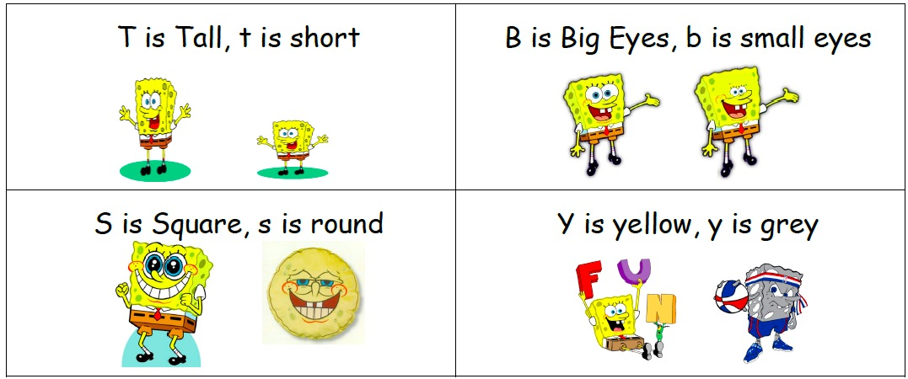

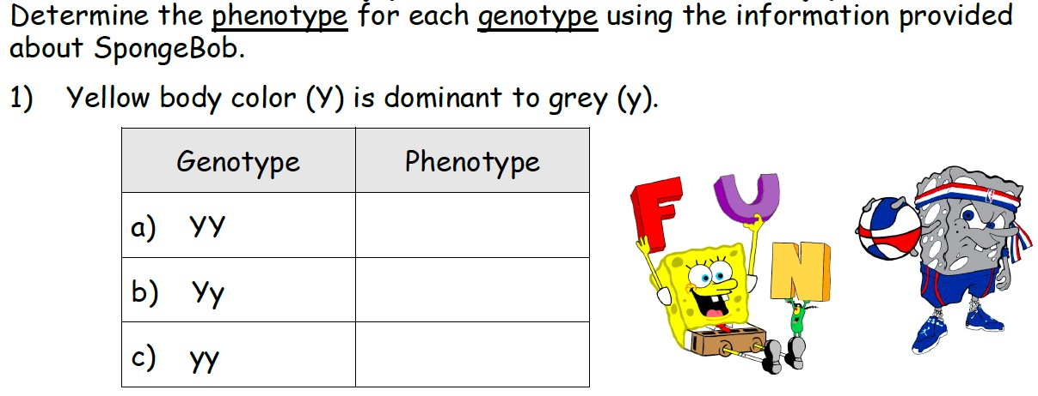
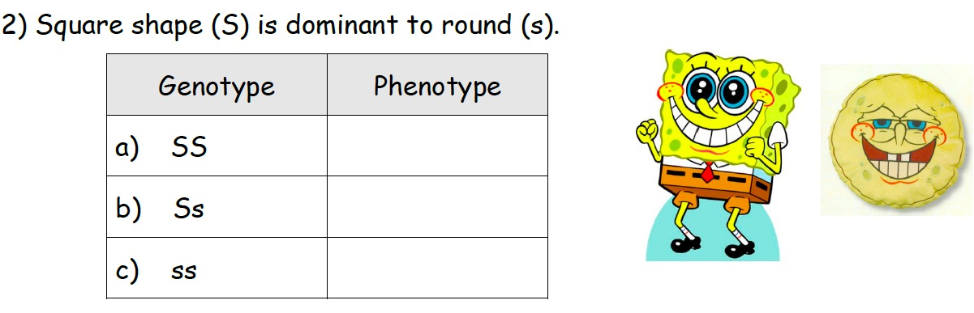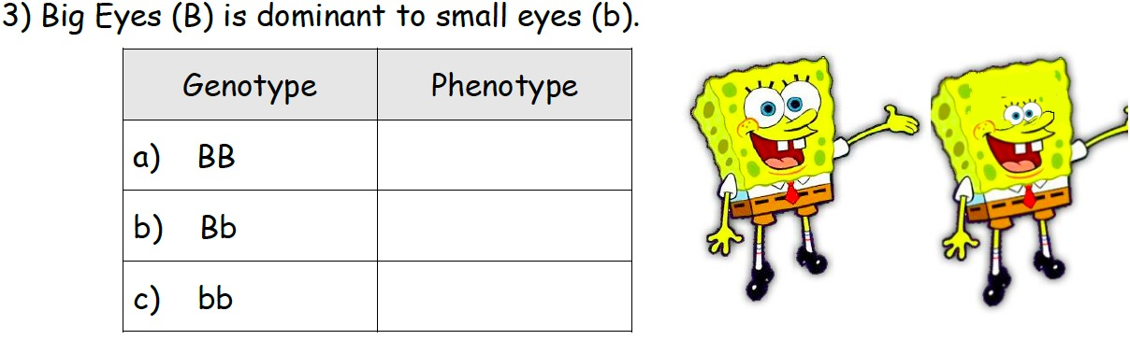

Rules for Punnett Squares

- Identify the dominant and recessive alleles. Make a key.

- Identify the parents’ genotype in the cross.

- Draw a Punnett Square. Place the parents genotype at the top and left side of the boxes

- Combine the genotypes for each box. (Down, Down, Across, Across)

5) Write out the genotypes and phenotypes for all offspring and calculate probability.

6) Answer questions.

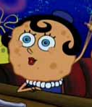
1. SpongeBob Square Pants recently met Sponge Susie Roundpants at a dance. SpongeBob is heterozygous for his square shape, but Sponge Susie is round. Create a Punnett square to show the possibilities that would result if SpongeBob and Sponge Susie had children.
Key:
____ = Dominate (________________)
____ = Recessive (________________)

All possible genotypes and phenotypes
____ =
____ =
____=
___ ___ x ___ ___

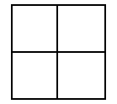

Genotype | Phenotype | Frequency | Probability (%)

2. SpongeBob is homozygous for his round eyes, but Sponge Susie is heterozygous for round eyes. Create a Punnett square to show the possibilities that would result if SpongeBob and Sponge Susie had children.

Key:
____ = Dominate (________________)
____ = Recessive (________________)

All possible genotypes and phenotypes
____ =
____ =
____=
___ ___ x ___ ___

Genotype | Phenotype | Frequency | Probability (%)

3. Tall Sponge Susie (TT) and short Sponge Bob (tt).

Key:
____ = Dominate (________________)
____ = Recessive (________________)

All possible genotypes and phenotypes
____ =
____ =
____=
___ ___ x ___ ___

Genotype | Phenotype | Frequency | Probability (%)

4. A gray Sponge Susie and a homozygous dominate yellow Sponge Bob.

Key:
____ = Dominate (________________)
____ = Recessive (________________)

All possible genotypes and phenotypes
____ =
____ =
____=
___ ___ x ___ ___

Genotype | Phenotype | Frequency | Probability (%)

Name: _______________________________________________ Date:_____________________
Teacher: _____________________ Lab: _________

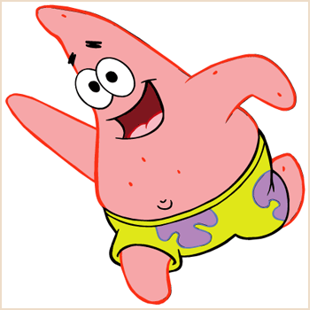
Sponge Bob Genetics 2
Complete the following worksheet. Use the rules for completing a Punnett Square.

5. Patrick met Patti at the dance. Both of them are heterozygous for their pink body color, which is dominant over a yellow body color. Create a Punnett square to show the possibilities that would result if Patrick and Patti had children.
Key:
____ = Dominate (________________)
____ = Recessive (________________)

All possible genotypes and phenotypes
____ =
____ =
____=
___ ___ x ___ ___

Genotype | Phenotype | Frequency | Probability (%)

6. Everyone in Squidward’s family has light blue skin, which is the dominant trait for body color in his hometown of Squid Valley. His family brags that they are a “purebred” line. He recently married a nice girl who has light green skin, which is a recessive trait. Create a Punnett square to show the possibilities that would result if Squidward and his new bride had children. Use B to represent the dominant gene and b to represent the recessive gene.

___ ___ x ___ ___
Key:
____ =
____ =
All possible genotypes and phenotypes
____ =
____ =
____=

Genotype | Phenotype | Frequency | Probability (%)

7. Assume that one of Squidward’s sons, who is heterozygous for the light blue body color, married a girl that was also heterozygous. Create a Punnett square to show the possibilities that would result if they had children.
Key:
____ =
____ =
All possible genotypes and phenotypes
____ =
____ =
____=

___ ___ x ___ ___

Genotype | Phenotype | Frequency | Probability (%)

8. Mr. Krabbs and his wife recently had a Lil’ Krabby, but it has not been a happy occasion for them. Mrs. Krabbs has been upset since she first saw her new baby who had short eyeballs. She claims that the hospital goofed and mixed up her baby with someone else’s baby. Mr. Krabbs is homozygous for his tall eyeballs, while his wife is heterozygous for her tall eyeballs. Some members of her family have short eyes, which is the recessive trait. Create a Punnett square using T for the dominant gene and t for the recessive one.

Genotype | Phenotype | Frequency | Probability (%)

8a. Did the hospital make a mistake? Explain your answer

