Name: _______________________________________________ Date:_____________________
Base Group Teacher: _____________________ Lab: _________

Dodging Extinction
Do Now:
The dichotomous key below provides a way to classify some animals into groups according to their physical characteristics.
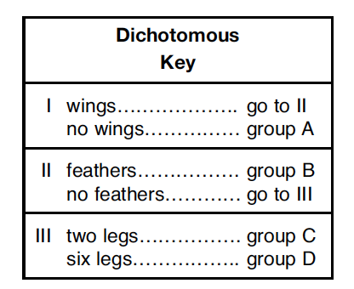

The key can be used to classify each of the four animals represented below.

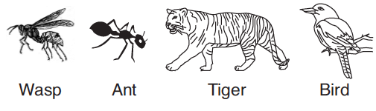

3. Which row in the chart shows the correct classification group for each animal?

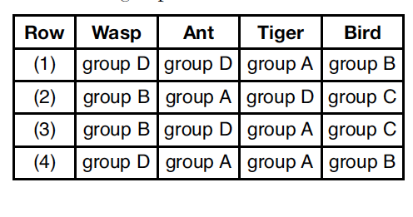
1. Living things are classified as producers or consumers according to

(1) their speed of movement
(2) the size of their communities
(3) how they obtain food
(4) how they reproduce
The diagram below represents a food web.
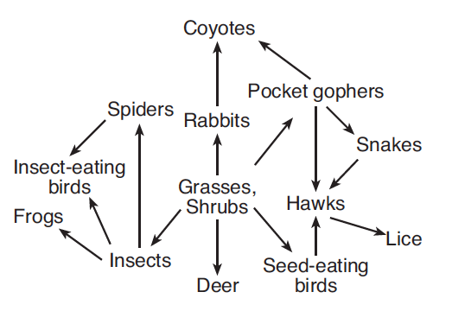
2. Which statement regarding organisms in this food web is correct?
(1) There would be more snakes than pocket gophers.
(2) There would be more coyotes than rabbits.
(3) There would be more insects than insect-eating birds.
(4) There would be more hawks than seed-eating birds.

1. Read this sentence from paragraph 10.
"The Monks also help educate local people about saving the majestic animals."
What does the word "majestic" suggest about the snow leopard?

A The monks think the snow leopards are dangerous.
B To describe the snow leopards as honorable and beautiful creatures.
C To alarm the readers of potential dangers snow leopards can be to the village
D In China, snow leopards are spiritual and protected creatures.

2. Read this sentence from paragraph 1.
“Catching a glimpse of one of the worlds most elusive animals requires trekking to the top of the world: Tibet, a mountainous region in China”.
What does the word "elusive" suggest about the snow leopard?

A The snow leopard is hard to find and is not often seen.
B The snow leopard is popular in Tibet and people travel to Tibet to see the snow leopard.
C Snow leopards are fast, cunning and dangerous animals.
D The snow leopard is weak and sickly.

3. Read this sentence from paragraph 4.
“In addition, they raise domesticated sheep, goats, and yaks, which compete with the wild animals for sparse grasses to eat”.
What does the word "sparse" suggest about the grasses?
A The grasses are invasive and kill other types of plants.
B There is plenty of grasses for the sheep, goats and yaks to eat.
C There is very little grass for the wild life to eat.
D The grasses are wild and are not available to the domesticated animals.

4. Cite two specific details from the text can you use to support that the snow leopard is hard to track.

5. What is the author's purpose in writing this article? Cite two reasons to support your claim.

6. Cite two reasons from the text that explain why the snow leopards are endangered.

