Name: _______________________________________________ Date:_____________________
Teacher: _____________________ Lab: _________

The Scientific Method
Observation, Hypothesis and Inference: What’s the Difference?

After this lesson you should be familiar with the differences between an observation, inference, and hypothesis.

Basic Steps of the Scientific Method

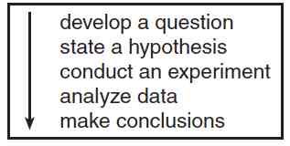

 | Observation | Inference | Hypothesis
Definition | An observation is a | An inference is a | A hypothesis is
Examples | June eats a lot of chocolate and has a lot of pimples. | June eats has a lot of pimples because she eats a lot of chocolate. | If June increases the amount she eats chocolate, then the amount of pimples on her face will increase.

***An observation must be UNBIASED in science.

Qualitative vs. Quantitative Observations

Qualitative observations are observations that are made with your five senses.

Example: 1. ____________________________________________________

2. ____________________________________________________

Quantitative observations are observations made as measurements and quantities.

Example: 1. ____________________________________________________

2. ____________________________________________________

