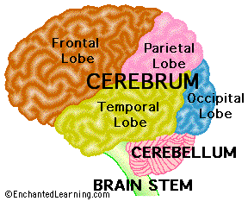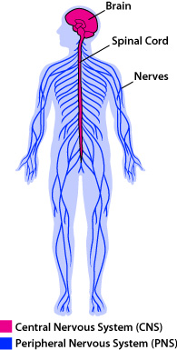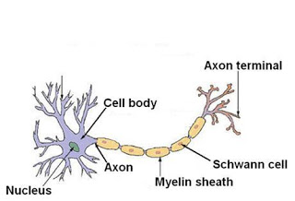

<http://askabiologist.asu.edu/parts-nervous-system>

<http://www.nature.com/scitable/blog/brain-metrics/are_there_really_as_many>

<http://www.livescience.com/12916-10-facts-human-brain.html>

<http://en.wikipedia.org/wiki/Alzheimer's_disease>

Figure 1

Websites Used:

**Nervous System Function**

According to the article by Ms. Scherben, the **nervous system** is control the center of the body. It coordinates the movement, it sends information from nerves in the body the brain.

**Why the Nervous System is Important:**

The **nervous system** is important because with out it you would not be able to walk, run, think or get out of the danger.

Every emotion, memory, idea or movement you have experienced is because of your Nervous system.

**According to Nature Magazine**, there are more nerves in the human there are stars in the Milky Way.

According to a LiveScience article, The average adult brain weighs just under 3 pounds and feels like tofu.

In the same article it states that teenage brains are fully formed yet. Most teenagers have undeveloped frontal lobes that are responsible for empathy and decision making.

Figure 1 shows the different parts of the brain. The brain is a major organ in the nervous system

## Interesting Facts About the Nervous System

## The Nervous System: Its function and why it is important.

The Nervous System

Ms. Scherben, 9/24/2013

Lab 8G

Figure 3

Figure 2

**Parts of the Nervous System**

The **nervous system** is a very complicated organ system but it does not have many organs. It is made up of the:

* Brain
* Spinal Chord
* Neurons

You can see an illustration of these parts of the nervous system in figure 2.

**Diseases Affecting the Nervous System**

There are many diseasing affecting the nervous system but Alzheimer's Disease is one that affects many families. The disease is caused by a “plaque,” that forms around the neurons and causes them to die.

According to Wikipedia, Alzheimer’s’ Disease is an impairment in cognitive function (thinking) that mostly includes an decline in memory and language. It mostly affects the elderly. In severe cases, the condition can make the patient forget their family members and require 24/7 medical care.

D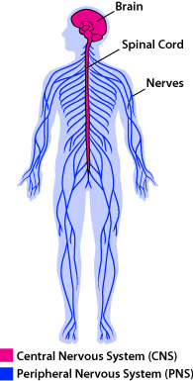

**Diseases that Affect the Nervous System:**

The Neuron Figure 3 shows the specialized cell of the nervous system. It sends information from one part of the body to the next

# Vocabulary

Nervous System: The organ system made up of nerves, brain and spinal chord. It controls all parts of the body and senses.

Neuron: Is the specialized cell in nervous system. It sends information to and from one neuron to another.