Name: _____________________________ Date: _______________Base Group: _____________ Lab: _____
Genetic Counseling
Do Now: Complete problem 1 and start problem 2.
1. Identify the following genotypes. The first three are done for you.

- DD homozygous dominate
- Dd heterozygous
- dd homozygous recessive
- GG ______________________________
- hh ______________________________
- Tt ______________________________

2. In humans, ear lob attachment is inherited. Detached earlobes are a dominant allele (E) over attached ear lobes (e). Using the “Steps for Solving a Punnett Square” on your yellow paper, cross a parent with attached earlobes with a parent who is heterozygous with detached ear lobes.
Key:

E = dominant allele, detached

e = __________ allele, ___________

All possible genotypes and phenotypes

EE = Detached Earlobes

Ee =

ee = attached earlobe
Parents Genotypes
________________ x ________________

Genotype | Phenotype | Frequency | Probability (%)
EE (homozygous dominate) | Detached Earlobe
Ee (heterozygous)

ee (homozygous recessive) | Attached Earlobe

Today you are Genetic Counselors, doctors and medical professionals who advise your families on certain rained to help families understand genetic disorders and to provide information and support to those families.

Your chief (the boss of a medical department) will be evaluating your performance at ever step. The Chiefs want to make sure that the families that are coming to you for advice are getting accurate information and that the families understand how you came to your conclusions.

Each team of doctors will be visited by a couple that plans on having a child. Your team will have answer their questions and present your research to them. Here is what needs to be present in each of your reports.

Figures:
- A key determining all the possible genotypes and phenotypes.

- A completed Punnett Square. (Use your yellow sheet to help you and your do now to make sure you didn’t forget anything).

- A chart of the possible genotype and phenotypes of their future children that include the frequency and probability.
In your written summary, you should use the strategies taught in ELA. Be sure to should be sure to include:
- A summary of the genetic disorder and how it is inherited. Feel free to include an interesting fact.

- The genotypes and phenotypes of the parents

- The possible genotype and phenotypes of the offspring and their frequencies and probabilities.

- Details from the figures you drew.

Format of the Poster:
- Your poster should include Title and Names.

- Your figures should be labeled with a caption.

Doctor ___________________________________ GD 1 (B)
Doctor ___________________________________

“Sonia’s Father” by Dr. Scherben
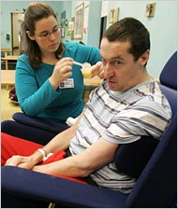
Huntington's Disease is a devastating, degenerative brain disorder for which there is, at present, no effective treatment or cure. Huntington’s slowly diminishes the affected individual's ability to walk, think, talk and reason. Eventually, the person with the disease becomes totally dependent means that people with Huntington’s disease usually have a family before they know they have it. Huntington’s disease is a dominant trait-which means you only need to inherit one copy of the allele to have the disease.

Sonia, a sixteen year old girl, comes to your office. She has recently found out that her father has Huntington’s Disease and is heterozygous. Her mother was tested and does not have the gene. Sonia, wants to know the probability of her having the genetic disorder. Let H = Huntington’s Disease and h = healthy.
Picture 1: Sonia with her father. Before he had Huntington's Disease Sonia's father was police officer.

Doctor ___________________________________ GD 3 (D)
Doctor ___________________________________

You recently received an email from a grandmother. She is concerned about her grand daughter and wants to know if she will become sick.

From: Marissa Gutierrez
To: Innovate Manhattan Hospital Genetic Counseling
Subject: My Granddaughter

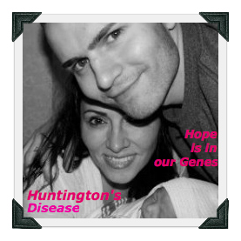
“There’s this boy, he calls me Mom and although he is now 23, he will always be my “baby.” Last year, my son was diagnosed with Huntington’s Disease (HD). Huntington’s disease is a hereditary, degenerative, and terminal brain disease. Huntington’s Disease (HD) slowly diminishes the affected individual’s ability to walk, talk, and reason. In time, the person with Huntington’s Disease relies completely upon others for their personal care.
HD affects the lives of entire families – emotionally, psychologically, socially, and economically. Huntington’s Disease affects males, females, and knows no ethnic or racial boundaries. I have promised my son that he will not fight this fight alone. I am with him every step of the way. However, I am concerned that his daughter might have the gene. His wife shows no sign of HD. We know that HD is caused by a dominant allele. Please help me know what the chances that my grandchild will have HD.”
Picture 1: My son, his wife and my granddaughter. Sadly my son will soon will not be able to speak or do anything on his own.

Doctor ___________________________________ GD 4 (B)
Doctor ___________________________________

“Will Joan and Manny’s Child Have Cystic Fibrosis?” By Dr. Scherben
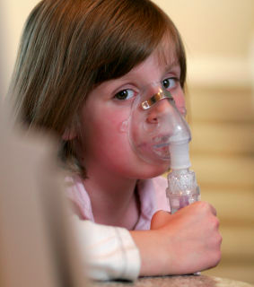
Cystic fibrosis (CF) is an inherited chronic disease that affects the lungs and digestive systems of about 30,000 children and adults in the United States. A defective gene causes the body to produce unusually thick, sticky mucus that clogs the lungs and leads to life-threatening lung infections and obstructs the pancreas. 50 years ago few children with cystic fibrosis lived to attend elementary school. Today many people with CF live into their 30’s and 40’s and beyond due to advances in treating the disease. Unfortunately, there is no cure for the disease. Cystic fibrosis caused by a single gene and is a recessive trait; therefore both copies of the gene must be present for the person to be affected.
Picture 1: People with CF have to spend hours every day getting medicine through special machine that helps them get the medicine directly to their lungs.
A couple, Joan and Emmanuel, are ready to have a child. After genetic testing you discover that both are carriers for the Cystic fibrosis gene. A carrier means that the person has the gene but does not show the symptoms of the disease. Let the dominate allele be C = healthy and recessive allele c= Cystic fibrosis.

Doctor ___________________________________ GD 5 (E)
Doctor ___________________________________

“Our Mothers Had Cystic Fibrosis. Will Our Future Child?” By Dr. Scherben

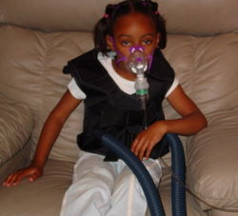
Cystic fibrosis (CF) is an inherited chronic disease that affects the lungs and digestive systems of about 30,000 children and adults in the United States. A defective gene causes the body to produce unusually thick, sticky mucus that clogs the lungs and leads to life-threatening lung infections and obstructs the pancreas. 50 years ago few children with cystic fibrosis lived to attend elementary school. Today many people with CF live into their 30’s and 40’s and beyond due to advances in treating the disease. Unfortunately however there is no cure for the disease. Cystic fibrosis caused by a single gene and is a recessive trait; therefore, both copies of the gene must be present for the person to be affected.
Picture 1: People with CF have to spend hours every day getting medicine through special machine that helps them get the medicine directly to their lungs.
Mercedes and Daquan are recently married and want to have a child. However, they are worried. They both met at a support group for children of parents with Cystic fibrosis when they were younger. Both of their mothers had the genetic disorder. However, both of their fathers were not carriers for the gene. A carrier is someone who has the gene but does not show symptoms. They want to know what their chances of having a healthy baby would be.
*Hint you will need to figure out what Mercedes and Daquan’s genotype is by first doing a Punnett Square of their mother and father.

Doctor ___________________________________ GD 6 (A)
Doctor ___________________________________

“A Funny Name for a Fatal Genetic Disorder?” By Dr. Scherben
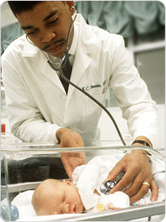
Maple Syrup Urine Disease (MSUD) is inherited in when a child inherits a recessive gene from both parents. A person with MSUD cannot break down certain amino acids in proteins. Therefore, they end up with dangerously high levels of these amino acids in their blood. A baby who has the disorder may appear normal at birth. But within three to four days, the symptoms appear. These may include: loss of appetite, fussiness, and sweet-smelling urine. The elevated levels of amino acids in the urine generate the smell, which is similar to maple syrup. If left untreated MSUD can cause coma, seizers or death.
Picture 1: A doctor examines a new born. The main symptom that helps doctors diagnosis if a child has MSUD is sweet smelling urine that smells like maple syrup.
Maria and Derek, visit your office at Innovate Manhattan Hospital because they are planning on having their first child. You run genetic testing and find that they both are carriers for the recessive MSUD gene. This means both Maria and Derek have the gene but don’t show symptoms, therefore they are both heterozygous (Mm). You now must explain to the couple the probability of them having a child with MSUD (mm), a carrier (Mm) or healthy (MM). Let the dominate allele M = healthy and the recessive allele m = Maple Syrup Urine Disease.

Doctor ___________________________________ GD 7 (B)
Doctor ___________________________________

“If One Parent is Carrier Can the Offspring Have the Disease?” By Dr. Scherben

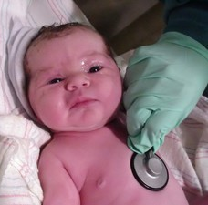
Maple Syrup Urine Disease (MSUD) is inherited in when a child inherits a recessive gene from both parents. A person with MSUD cannot break down certain amino acids in proteins. Therefore, they end up with dangerously high levels of these amino acids in their blood. A baby who has the disorder may appear normal at birth. But within three to four days, the symptoms appear. These may include: loss of appetite, fussiness, and sweet-smelling urine. The elevated levels of amino acids in the urine generate the smell, which is similar to maple syrup.
Picture 1: A doctor examines a new born. The main symptom that helps doctors diagnosis if a child has MSUD is sweet smelling urine that smells like maple syrup syndrome.
Nailah and Carlos, are a healthy couple that is planning to have a child. They visit your office at Innovate Manhattan Hospital for genetic counseling. Your team of doctors discovers that Carlos is a carrier but Nailah is not. A carrier is someone who has the gene but does not show symptoms. This means that a carrier is heterozygous. You now must explain to the couple the probability of them having a child with MSUD (mm), a carrier (Mm) or healthy (MM). Let the dominant allele M = healthy and the recessive allele m = Maple Syrup Urine Disease.

Doctor ___________________________________ GD 8 (B)
Doctor ___________________________________

“Will Our Babies Be Healthy?” By Dr. Scherben
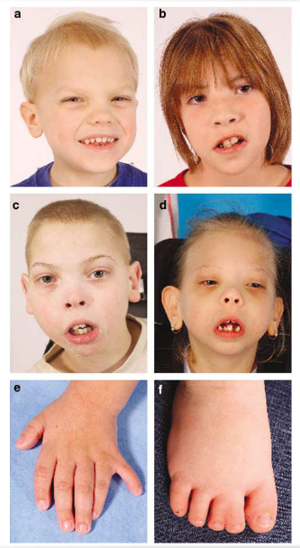

Smith-Lemli-Opitz syndrome (SLOS) is a serious genetic disorder. People who have SLOS are unable to make enough cholesterol to support normal growth and development. Cholesterol is an essential component of the cell membrane and tissues of the brain. A person who can't make enough cholesterol will therefore experience poor growth, developmental delays, and mental retardation. People with this disorder may also have a range of physical malformations (such as extra fingers or toes) and problems with internal organs (such as the heart or kidney).
SLOS is caused by a recessive allele. That means that the trait has to be inherited by both parents in order to get the disease. Yvette and Don, a healthy couple comes to your office at Innovate Manhattan Hospital because they are planning to have a child. After genetic testing you discover that Yvette is a carrier. This means that she has the gene but shows no symptoms. Don does not have the gene. He is homozygous dominant. Let the dominant allele S = healthy and the recessive allele s = Smith-Lemli-Opitz syndrome. They want to know what their chances of having a healthy baby would be.
Pictures a-f: Typical Facial Features and Physical Findings in SLOS. (a – d) Facial photographs of a series of SLOS patients of different severity (e) Limb anomalies include extra fingers or toes, or finger or toes bound together.

Doctor ___________________________________ GD 9 (E)
Doctor ___________________________________

“Does Martin have Marfan’s Syndrome?” by Dr. Scherben

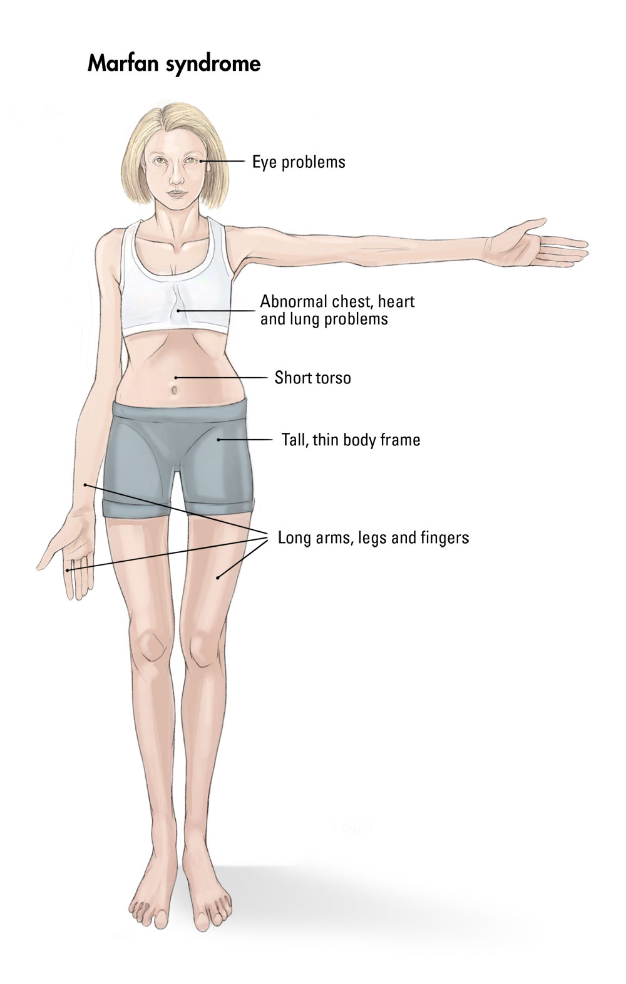
Marfan syndrome is an inherited disorder that affects connective tissue — the fibers that support and anchor your organs and other structures in your body. Marfan syndrome most commonly affects the heart, eyes, blood vessels and skeleton. People with Marfan syndrome are usually tall and thin with even longer arms, legs, fingers and toes. It does not affect your intelligence but it sometimes can cause health problems.
Martin and Ashley are a cheerful couple. They come to Innovate Manhattan Hospital for genetic counseling. You notice that Martin is extremely tall and thin and when he shakes your hand you see that his fingers are extremely long. He does not mention that he has Marfan syndrome but sometimes people do not know they have the disease. You ask him if his parents were as tall as him. He reports that his father is taller and has a similar stature, but his mother is of normal height. His wife Ashley is tall but she is of normal stature. Marfan syndrome is caused by a dominant allele. Let the dominant allele F= Marfan syndrome and the recessive allele f = normal stature. Will their child have Marfan syndrome?
Picture 1: The stature of a person with Marfan syndrome
Picture 2 Martin and Ashley met in college during orientation.

Doctor ___________________________________ GD 10 (A)
Doctor ___________________________________

“Will Our Child be a Giant?” by Dr. Scherben

Marfan syndrome is an inherited disorder that affects connective tissue — the fibers that support and anchor your organs and other structures in your body. Marfan syndrome most commonly affects the heart, eyes, blood vessels and skeleton. People with Marfan syndrome are usually very tall and thin with even longer arms, legs, fingers and toes. It does not affect your intelligence but it sometimes can cause health problems.
Doug and Leslie are hoping to have a baby. They come to Innovate Manhattan Hospital for genetic counseling. Leslie has Marfan syndrome and is heterozygous (Ff) and Doug does not have Marfan’s syndrome he is homozygous recessive (ff). They want to know what the probability that their future child will have Marfan syndrome would be. Let the dominant allele F= Marfan syndrome and the recessive allele f = normal stature.
Picture 1: The stature of a person with Marfan syndrome

Doctor ___________________________________ GD 11 (F)
Doctor ___________________________________

“We Have the Smallest Girl in the World.” by Dr. Scherben

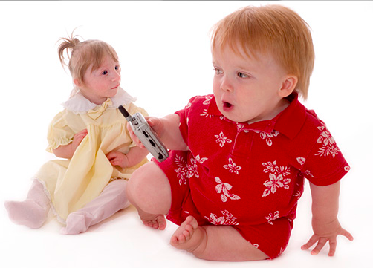
Kenadie is the smallest girl in the world because she has primordial dwarfism. Primordial has been defined as belonging to or being characteristic of the earliest stages of development of an organism. Therefore, Primordial Dwarfism is a class of disorders where growth delay occurs at the earliest stages of development. Unlike some of the other forms of dwarfism where newborn infants can have average lengths, children with Primordial Dwarfism are born smaller than average and have intrauterine growth retardation (IUGR).
Picture 1: Kendrie with her parents at the age of two.

Kenadie’s parents come to Innovate Manhattan Hospital. They were so worried when they had Kendadie because they knew she was very small while her mother was pregnant and when she was born she was not much more than 2 pounds. Kenadie lives life as much as she can for someone has her size but her parents are worried because they don’t know of any primordial dwarfs that have live to adulthood.
Picture 2: Kenadie (primordial dwarfism) with Jake (Achondroplastic Dwarfism) Both age 2

They want to have another child but they know very little about how Kenadie became a dwarf and they want to know if their second child will be a dwarf as well. You need to use your clues to figure out if primordial dwarfism is a dominate or recessive allele and what the possible genotypes of Kendrie’s parents. Then complete your project.
Picture 3: Kendrie at seven years old with her second grade class celebrating Halloween.

Doctor ___________________________________ GD 12s (A)
Doctor ___________________________________

“We Have the Smallest Girl in the World.” by Dr. Scherben

Kenadie is the smallest girl in the world because she has primordial dwarfism. Primordial has been defined as belonging to or being characteristic of the earliest stages of development of an organism. Therefore, Primordial Dwarfism is a class of disorders where growth delay occurs at the earliest stages of development. Unlike some of the other forms of dwarfism where newborn infants can have average lengths, children with Primordial Dwarfism are born smaller than average and have intrauterine growth retardation (IUGR).
Picture 1: Kendrie with her parents at the age of two.

Kenadie’s parents come to Innovate Manhattan Hospital. They were so worried when they had Kendadie because they knew she was very small while her mother was pregnant and when she was born she was not much more than 2 pounds. Kenadie lives life as much as she can for someone has her size but her parents are worried because they don’t know of any primordial dwarfs that have live to adulthood.
Picture 2: Kenadie (primordial dwarfism) with Jake (Achondroplastic Dwarfism) Both age 2

They want to have another child but they know very little about how Kenadie became a dwarf and they want to know if their second child will be a dwarf as well. Primordial dwarfism is caused by a recessive allele. Both of Kenadie’s parents are heterozygous (Pp). Kenadie’s genotype is homozygous recessive (pp).
Picture 3: Kendrie at seven years old with her second grade class celebrating Halloween.

Small wonder: Junrey Balawing is set to become the world's smallest man when he turns 18 in June. Junrey stands at just 22 inches tall
Read more: http://www.dailymail.co.uk/news/article-1364609/Make-small-The-teenager-set-worlds-shortest-man-just-22-INCHES-high.html#ixzz2SR5Ykokp
Follow us: @MailOnline on Twitter | DailyMail on Facebook

