Name: _______________________________________________ Date:_____________________
Teacher: _____________________ Lab: _________

Dates: (9/17 – ______________ )

THE EVERY BODY PROJECT
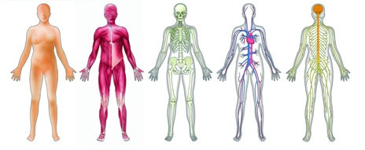

Class | Science | Social Studies | Art
What I will learn | The different types of organ systems and organisms. The requirements of this project. | How to use multiple sources and site them. The art of presentations | How biological illustrations are used for learning. Text supports.
What I will create/ How will I be assessed | A brochure of your body system that will be distributed to the class. | A presentation of your group’s body system. Be sure to have your brochure, power point and poster ready. | A life sized drawing of your organ system with text supports.
Lab Dates | 9/17-9/20 | 9/17 – | 9/17 –
Due Date

Working Goals:

- You will be working in groups to create a life-sized poster of an organ system.
- A brochure that your peers can use to learn about the organ system you created.
- A power point presentation that is no longer that 5 minutes and 6 slides.
- Competed organ system worksheet after your peers presentation.

Why are we doing three types of presentations on the same body system?

- This way everyone contributes.
- We are not just learning about the human body we are also learning about how to present information, work collaboratively and non-fiction text supports.
- You are all teaching each other. A poster can’t fit in your classmates’ folder or be copied. Therefore, we need the brochure. If you are teaching the class a worksheet is usually not enough, teachers make power points to go along with their worksheets.

Poster, Brochure and Power Point Requirements
ALL THREE MUST HAVE THESE!

1. Name, date, lab
2. Appropriate text features (bold words, words defined in the sentence, tables, captions, titles)
3. A drawing or picture of your body system (poster life sized)
4. A explanation of the function of your body system and why it is important.
5. Identify the major organs and what each organ does (their job)
6. A disease or disorder associated with your system and its causes/effects.
7. Fun facts or “Did You Know?” about your body system.
8. A list of sources (listing of ALL resources used -- books, Internet, video. 4 minimum.)

Working Goal 1:
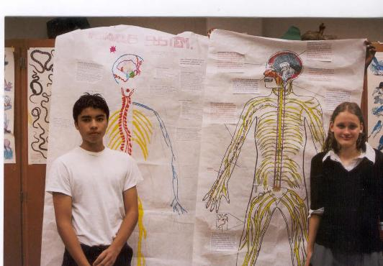
You will all work in groups of four. In this assignment your group will be assigned a body system.

You will trace a person and draw organ system in DETAIL!

You may use the internet to print out organs if you do not whish to draw.

IT MUST BE COLORFUL and ACCURATE.

Working Goal 2:
Your assignment is to create a two-sided (on a single piece of paper) information sheet and present it to your class. These will be combined to make an organ system packet for each student. Use either Microsoft Word or Publisher.

Working Goal 3:
Use google docs to create a power point. Share the power point with your peers and teachers. Keep it short and simple. I want to know that you can share the information in as little words as possible. Wordy slides are confusing and you should not read off of them when you are presenting.

Working Goal 4:
The attached sheet should be completed during your peers presentations. Make sure that your presentation has all of the information needed to fill out this sheet easily.

Mr. May will show you HOW TO CITE A SOURCE

Name: _______________________________________________ Date:_____________________
Teacher: _____________________ Lab: _________

THE EVERY BODY PROJECT
System | Major Structures | Functions | Associated Disease | Interesting Fact
System | Major Structures | Functions | Associated Disease | Interesting Fact

Organ Systems
Organ Systems for Project

Muscular system
Respiratory system
Circulatory system
Digestive system
Excretory system
Endocrine system

The nervous system will be taught in science and art will do the artistic tasks.

