Name: _______________________________________________ Date:_____________________

Base Group Teacher: _____________________ Lab: _________

Electromagnetic Waves

**Do Now:**

For the wave above, label the following: crest, through, amplitude, resting position and wavelength.

RADIANT ENERGY is the energy of electromagnetic waves.

# Electromagnetic Waves

Electromagnetic waves: A type of transverse waves that contain electric and magnetic parts. Examples: Light, Radio, and X-rays

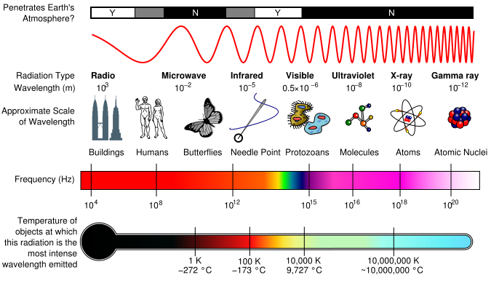

**DIRECTIONS**: Annotate important key points and terms.

**Waves in Empty Space**

On a clear night you might see the Moon shining brightly, as in **Figure 16.** Like other waves, light waves can travel through matter, but light waves are different from water waves and sound waves. Light from the Moon has traveled through space that contains almost no matter. You can see light from the moon, distant stars, and galaxies because light is an electromagnetic wave. **Electromagnetic waves** are waves that can travel through matter or through empty space and are a form of radiant energy.



Anelectromagnetic wave contains an electric part and a magnetic part, as shown in **Figure 17.** Both parts are called fields and vibrate at right angles to the wave motion.

**The Electromagnetic Spectrum**

**Figure 18** shows the different types of waves in the electromagnetic spectrum**.** The **electromagnetic spectrum** is the complete range of electromagnetic wave frequencies and wavelengths. At one end of the spectrum the waves have low frequency, long wavelength, and low energy. At the other end of the spectrum the waves have high frequency, short wavelength, and high energy. All of the waves—from radio waves to visible light to gamma rays— are the same kind of waves. They differ from each other only by their frequencies, wavelengths, and energy. The electromagnetic spectrum is organized by decreasing wave length and increasing frequency.



Radio Waves and Microwaves

The waves that carry radio and television signals to your home are radio waves. The wavelengths of radio waves are greater than about 0.3 meters. Some are even thousands of meters long. The shortest radio waves are called microwaves. These waves have a wavelength between about 0.3 meters and 0.001 meters. You use these waves when you cook food in a microwave oven. Microwaves are also used to transmit information to and from cell phones.

Infrared Waves When you use a remote control, infrared waves travel from the remote to a receiver on your television. **Infrared waves** have wavelengths between 0.001 meters and 700 billionths of a meter. All warm bodies emit infrared waves. Because of this, law enforcement officials and military personnel sometimes use special night goggles that are sensitive to infrared waves. These goggles can be used to help locate people in the dark.



Visible Light and Color The range of electromagnetic waves between 700 and 400 billionths of a meter is special, because that is the range of wavelengths people can see. Electromagnetic waves in this range are called visible light. **Figure 19** shows how different wavelengths correspond to different colors of light. White light, like the light from the Sun or a flashlight, is really a combination of different colors. You can see this by using a prism to separate white light into different colors. When the light passes through the prism, the different wavelengths of light are bent different amounts. Violet light is bent the most because it has the shortest wavelength. Red light is bent the least.

Ultraviolet Waves Electromagnetic waves with wavelengths between about 400 billionths and 10 billionths of a meter are **ultraviolet waves.** These wavelengths are shorter than those of visible light. Ultraviolet waves carry more energy than visible light waves. Sunlight that reaches Earth’s surface contains a small fraction of ultraviolet waves. These waves can cause sunburn if skin is exposed to sunlight for too long. Excessive exposure to ultraviolet waves can permanently damage skin, and in some cases cause skin cancer. However, some exposure to ultraviolet waves is needed for your body to make vitamin D, which helps form healthy bones and teeth.

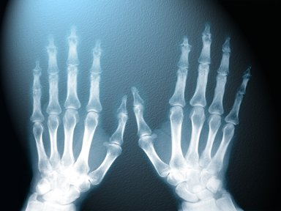X Rays and Gamma Rays The electromagnetic waves with the highest energy, highest frequency, and shortest wavelengths are X rays and gamma rays. If you’ve ever broken a bone, the doctor probably took an X ray to examine the injured area. X rays are energetic enough to pass through the body. X rays pass through soft tissues, but are blocked by denser body parts, such as bones. This enables images to be made of internal body parts. Gamma rays are even more energetic than X rays. One use of gamma rays is in the food industry to kill bacteria that might increase the rate of spoilage of food.



Electromagnetic Waves from the Sun Most of the energy emitted by the Sun is in the form of ultraviolet, visible, and infrared waves, as shown in **Figure 20.** These waves carry energy away from the Sun and spread out in all directions. Only a tiny fraction of this energy reaches Earth. Most of the ultraviolet waves from the Sun are blocked by Earth’s atmosphere. As a result, almost all energy from the Sun that reaches Earth’s surface is carried by infrared and visible electromagnetic waves.

**Using evidence from the passage and your ELA strategies, answer the following questions. Use complete sentences.**

1. According to the passage, what is the difference between electromagnetic waves and mechanical waves?
2. Define the electromagnetic spectrum.
3. How is the electromagnetic spectrum organized?
4. What type of electromagnetic wave has the lowest energy? What type of wave has the highest energy?
5. List the types of electromagnetic energy from the lowest amount of energy to the highest.

6. Complete this table:

|  |  |
| --- | --- |
| Electromagnetic Wave | Possible uses |
| visible light |  |
| ultraviolet light |  |
| x rays |  |
| microwaves |  |

**Applying Your Understanding**

We learned that electromagnetic energy travels in waves. There are various parts of waves that can tell us useful information about how much energy is in a wave. By the conclusion of class, you should be able to identify the parts of waves to determine which waves have more energy than others. In addition, you will be able to apply your new understanding of waves to explain the organization of the electromagnetic spectrum.

Use the area below to label the parts of waves:

Parts of waves: 1) Crest: 2) Trough: 3) Wavelength: 4) Amplitude:

Define frequency:

__________________________________________________________________________________________________________________________________________________________________________________

|  |  |
| --- | --- |
| What does a high frequency wave look like? Draw it. | What does a low frequency wave look like? Draw it. |

**Directions: Observe the picture below representing the colors of visible light and then use the information to answer the questions that follow.**

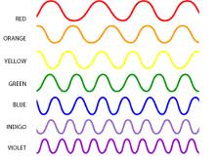

What color has the most electromagnetic energy? _________________________

What color has the longest wave length? ________________________

How does the energy of red compare to the energy of green? ____________________

What has more energy Blue or Violet? How do you know? ____________________________________________________________________________________________________________________________________________________________________________________________

**Directions: observe the image of the electromagnetic spectrum and use the information to answer the questions below.**

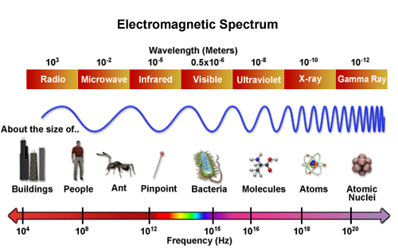

Based on your understanding of frequency and wavelength, what part of the EM spectrum has the most energy? ________________________________

Which part of the EM spectrum has the least amount of energy? ___________________

What has more electromagnetic energy, infrared radiation or x-rays? ________________

Why do X-rays have to be used to take pictures of broken bones, as opposed to infrared? __________________________________________________________________________________________________________________________________________________________________________________