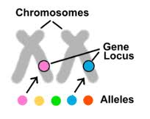
Each pair of chromosomes have two genes. One specific gene is called an ________________________. An allele is a singular gene that codes for a trait.
You can have a gene that codes for eye color but the alleles would be brown, green, blue or hazel.
When _________________________________________________________________ you get a ___________________________________. When we describe genotypes we use letters.

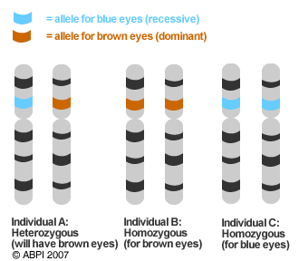
Alleles can be _________________________ or ________________________________.

A _______________________________ allele has a gene that is always expressed. It masks a recessive allele. It is represented by a capital letter (B).

A ________________________________ allele is only expressed if there is no dominate allele paired with it. IT is represented by a lower case letter (b).

You can describe genotypes in three ways: (remember heter-different, homo- same).

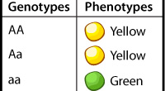
________________________________ describes a genotype that has a recessive and a dominate allele. (Bb, Hh, Tt)

_______________________________________ describes a genotype that has two dominate alleles. (BB, HH, TT).

________________________________________ describes a genotype that has two recessive alleles. (bb, hh, tt).

A ______________________________ is how that gene is expressed. We can observe phenotypes.

Dominate alleles ___________________ the recessive alleles.
Key:
____ = Dominate (________________)
____ = Recessive (________________)

All possible genotypes and phenotypes

____ =

____ =

____=
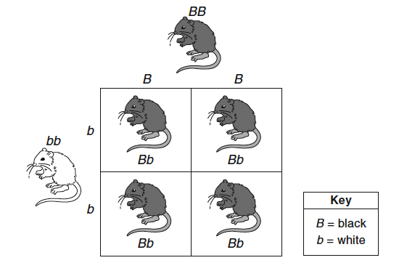

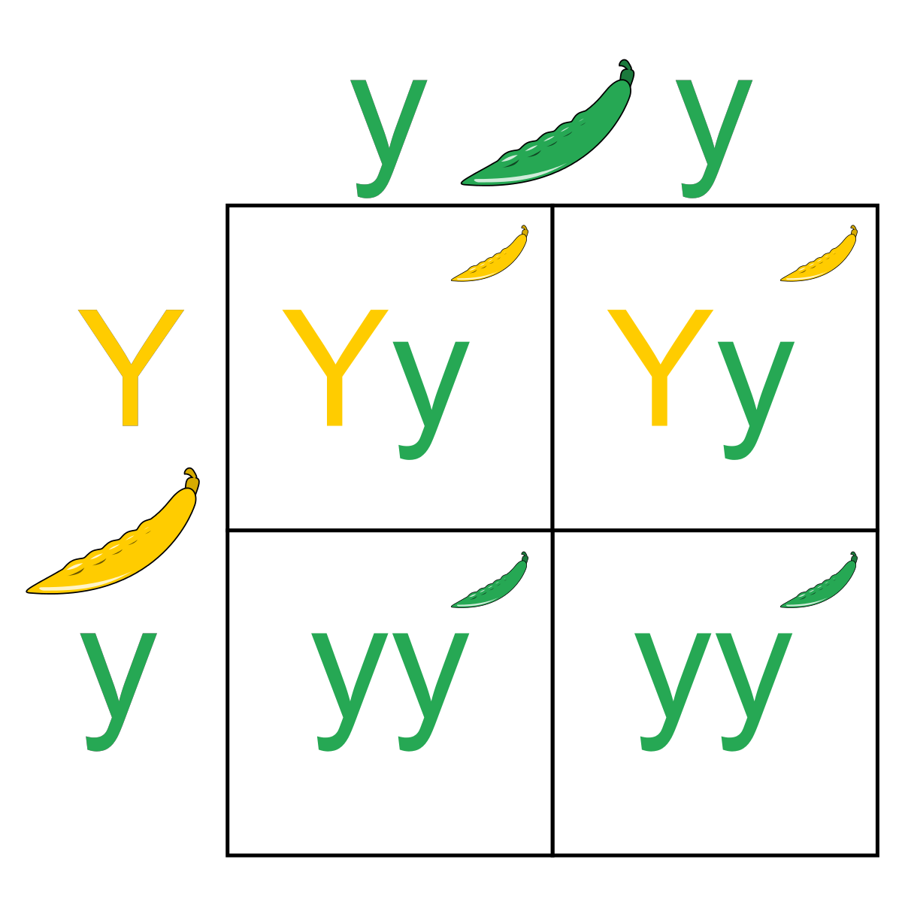
Key:
____ = Dominate (________________)
____ = Recessive (________________)

All possible genotypes and phenotypes

____ =

____ =

____=
Explain why the heterozygous genotype (Yy) has a phenotype of Yellow pod instead of a green pod.

Remember glue quickly along the dotted lines.
Lets make the glue last and we will never loose a stick or a cap!

