Name: _______________________________________________ Date:_____________________
Teacher: _____________________ Lab: _________

Controlled Experiments

Do Now: Write down these definitions.
Controlled Experiment:

Independent Variable:

Dependent Variable:

Control Variable:

Experimental Question: | Does soap or hand sanitizer kill more germs?
Hypothesis:  Choose which one you agree with | If a person uses hand sanitizer, then they will have fewer germs on their hands than when they use hand soap.  If a person uses hand soap, then they will have fewer germs on their hands than when they use hand sanitizer.
Reasoning | I think ________________________________________ will kill more germs because  __________________________________________________________________________________________________________________________________________________________________________
Experimental Design  Independent variable:  What am I purposefully changing?  Dependent Variable:  What will I look for in my result?  Control Variables: What might cause something to change in my experiment that is not the independent variable? | Independent Variable:  Dependent Variable:  Control Variables:

Procedure: Describe what happened in the experiment. (Class will type up. Print it out and attach.

Collect data: Every day in workshop come and collect data, or look at the pictures online.

Day | Drawing | Qualitative Observations | Quantitative Observations  # of Bacteria Colonies
 | 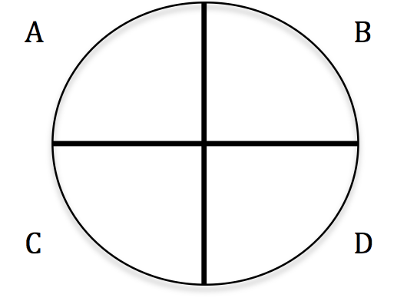 | A  B  C  D | A  B  C  D
 |  | A  B  C  D | A  B  C  D
 |  | A  B  C  D | A  B  C  D
 |  | A  B  C  D | A  B  C  D
 |  | A  B  C  D | AA  B  C  D

Analyze the data: Graph the quantitative results and summarize the qualitative results.

Draw your conclusion

