Name: _______________________________________________ Date:_____________________

Base Group Teacher: _____________________ Lab: _________

**Classification of Living Things**

Goal: I will be able to classify my endangered species.

I will be able to follow and create a dichotomous key.

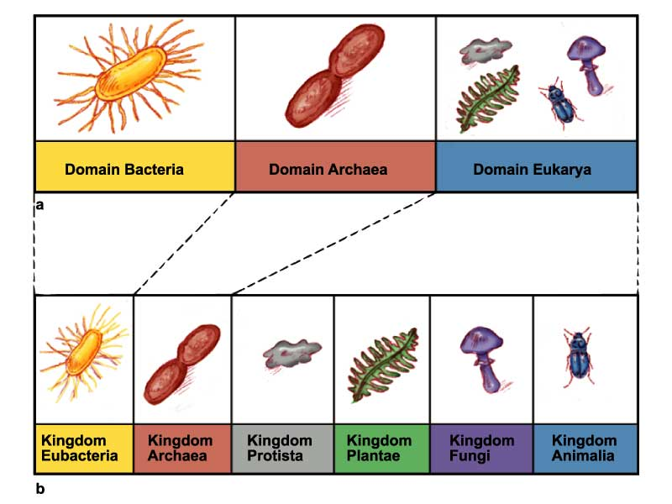

**What is classification?**

MC900151177.WMF

* : putting things into orderly groups based on similar characteristics
* : the science of describing, naming, and classifying organisms
* Aristotle grouped everything into simple groups such as animals or plants
* He then grouped animals according to if they had blood or didn’t have blood, and if they had live young or laid eggs, and so on…

**Binomial Nomenclature**

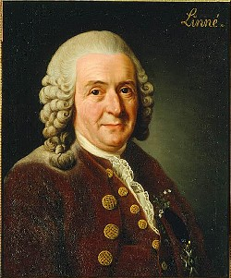

* Developed by _____________________________________
* Swedish Biologist 1700’s
* Two-name system
* Genus and species named using Latin or Greek words

**Rules used to write scientific names**

*Homo sapiens*

* An _______________________________ is always written __________________; the ___________________________ is always written _____________________
* The genus is Capitalized; the species is written in lower case
* Scientific names of organisms are always *italicized* or underline

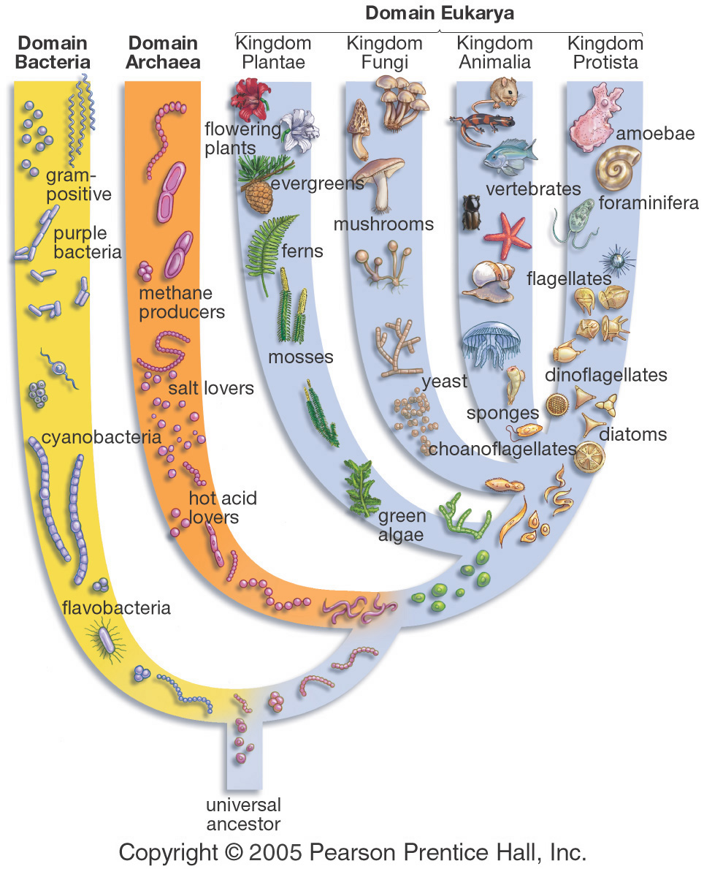**Modern Taxonomy**

The Evidence used to classify into taxon groups

* + 1) Embryology
  + 2)_________________________
  + 3) Biochemistry
  + 4) Physiology
  + 5) Evolution
  + 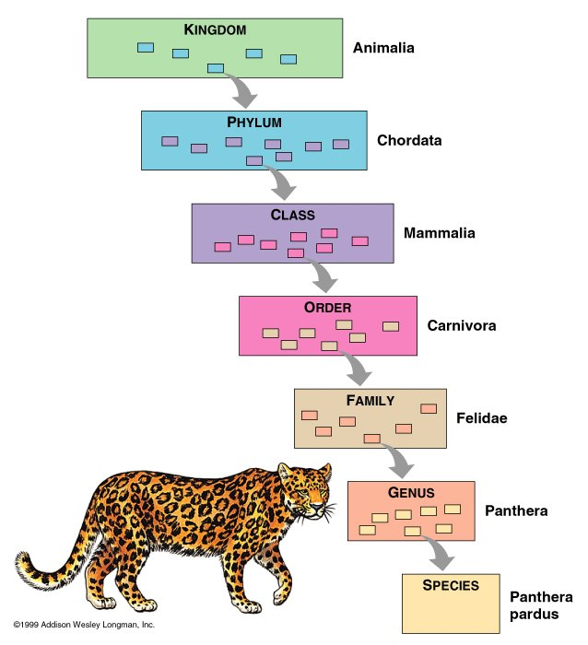  6) Behavior

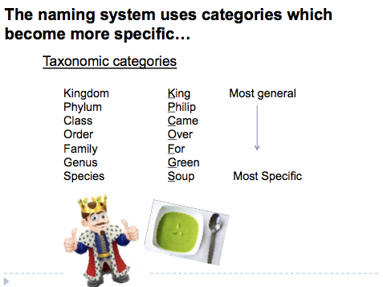

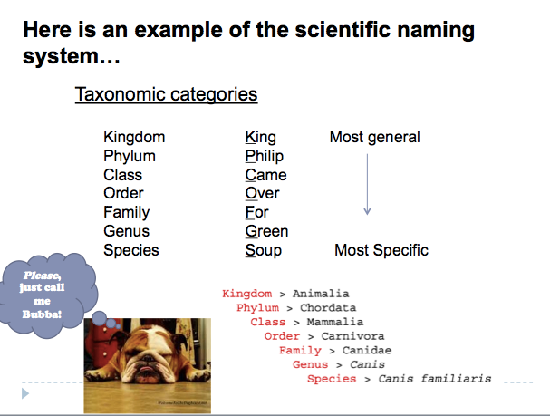

**Using the classification system**

Field guides help identify organisms.

-they highlight differences between similar organisms (like trees)

Taxonomic Key (Dichotomous Key)

-paired statements that describe the physical characteristics of different organisms

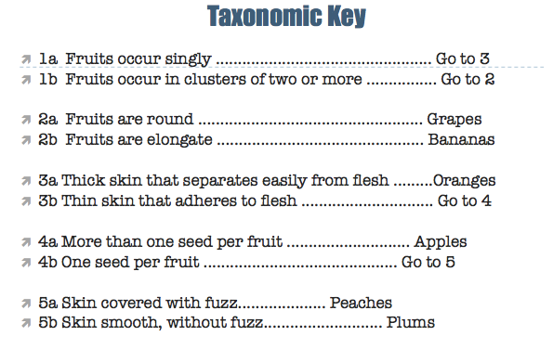

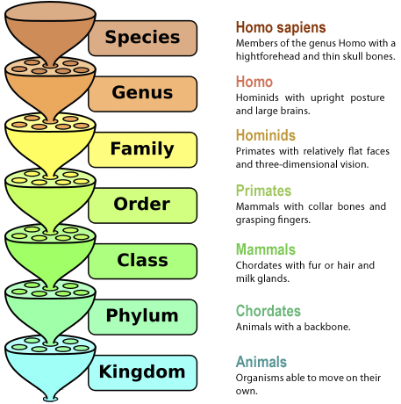

Name: _______________________________________________ Date:_____________________

Base Group Teacher: _____________________ Lab: _________

**Endangered Species Project**

Classify your species. Then complete the survey.

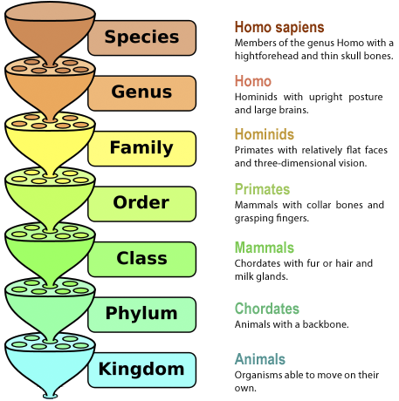

v

v