Name: _______________________________________________ Date:_____________________

Teacher: _____________________ Lab: _________

**Cell Division (Mitosis) & Reproduction**

**Practice Questions**

1. In humans, a fertilized egg contains 46 chromosomes. Which bar graph best represents the number of chromosomes contained in the sperm and egg before they united to make the fertilized egg?

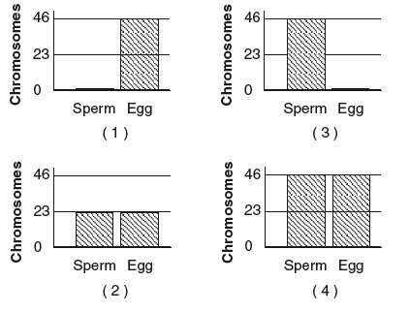

2. Which example would result in new cells that are most different from the parent cells?

(1) yeast cells splitting into new cells

(2) bacteria cells dividing into new cells

(3) skin cells dividing to produce more skin cells

(4) sperm and egg cells uniting to produce fertilized egg cells

3. In a one-celled organism, cell division is responsible for

(1) growth and maintenance

(2) sexual reproduction

(3) asexual reproduction

(4) production of sex cells

4.The diagram below shows three generations of cell division.



How many cells should exist in the fourth generation?

(1) 10 (3) 6

(2) 8 (4) 4

Base your answers to questions 5 and 6 on the diagram below and on your knowledge of science. The diagram represents a model of sexual reproduction in humans. Two stages are labeled A and B.

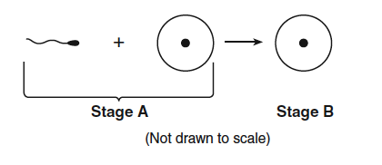

5 Identify each of the two cells represented at stage A. [1]

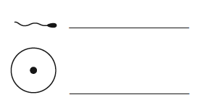

6 Describe one difference between sexual reproduction and asexual reproduction. [1]

________________________________________________________________________

________________________________________________________________________

Base your answers to questions 8 through 10 on the diagram below and on your knowledge of science. The diagram shows a model of sexual reproduction. The lines in each cell represent genetic material (chromosomes).

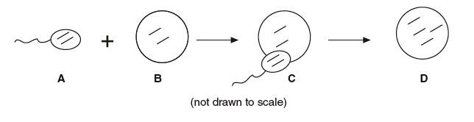

**8** Which letter in the diagram represents a female sex cell? [1]

**9** Which process is occurring at *C*? [1]

**10** What evidence in the diagram shows that sexual reproduction occurred? [1]

________________________________________________________________________________

11 The diagram below shows a one-celled organism reproducing.

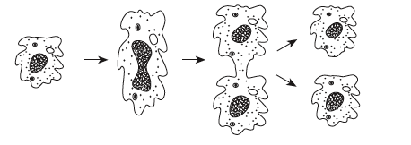

This is an example of asexual reproduction. What information in the diagram supports this statement? [1]

________________________________________________________________________________