Name: _______________________________________________ Date:_____________________
Base Group Teacher: _____________________ Lab: _________

Adaptations.

Environment
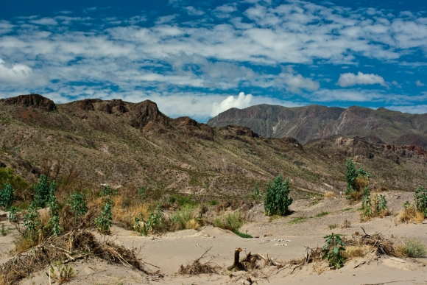
Desert: Characterized by sparse vegetation. Much of the vegetation is “xeorphytic”, having adapted itself to the dry conditions with long roots, thick bark, and other adaptations to retain moisture. Few trees. The desert your animal will be living in is very hot. There is very little water. Most water is underground or stored in tough and thick vegetation. There are long periods of time with no rain.

Food: Cactus, beetles and spiders, roots
Predators: Snakes and predatory birds
Other Considerations: Very hot in the daytime and cold temperatures at night. There are poisonous snakes and insects. There is very little places to find shelter and to hide. It is very easy to get dehydrated.

Tasks
You will imagine an animal with adaptations to survive the environment you have chosen. Your animal must have at least 5 adaptations, and describe your adaptations in the chart below.
- On another piece of paper put your name, class, date.
- Draw the environment and your creature.
- Label and describe each adaptation in your picture.

Adaptation | Description | Advantage for Survival

Name: _______________________________________________ Date:_____________________
Base Group Teacher: _____________________ Lab: _________

Adaptations.

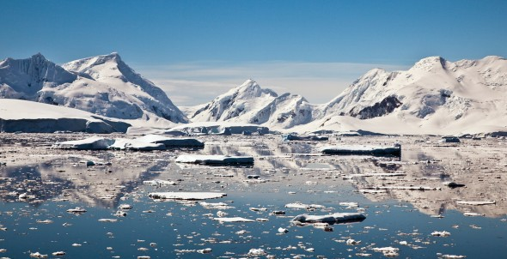
Artic: Very little to no vegetation. Life is precarious, at best, in this biome. However, there are a few animals that adapted to this harsh environment. It is very cold and most of the area is covered with ice and snow. Animals often have to migrate to different areas because the winter can be harsh and the summer can melt the ice shelf. Most food is found below the ice.

Food: Fish and penguins.
Predators: Polar bears and sea lions.
Other considerations: It is very hard to find vegetation. Slipping on the ice could lead to very dangerous situations but using the ice as a slide could make migrating easier. There are no places to hide. The ice can be very thick and hard to penetrate. Your food and predators live in the ice.

Tasks
You will imagine an animal with adaptations to survive the environment you have chosen. Your animal must have at least 5 adaptations, and describe your adaptations in the chart below.
- On another piece of paper put your name, class, date.
- Draw the environment and your creature.
- Label and describe each adaptation in your picture.

Adaptation | Description | Advantage for Survival

