The Incredible Cell Project
You will be required to construct a model of a plant cell. All models
must be made out of materials that will not spoil.
Your project must be labeled. You may label each organelle or create a
key. Use the questions in the grading section to help you develop a
good project.

Each model must include the following organelles:
• Cell wall • Ribosomes
• Cell membrane • Mitochondria
• Nucleus (w/ nucleolus & chromosomes) • Vacuoles
• Cytoplasm • Lysosomes
• Endoplasmic Reticulum (optional) • Chloroplasts
• Golgi Bodies (optional)

Grading:
Grades will be based on the following questions:
- Is your and your partners name on the project?
- Is the cell type identified?
- Is the model a 3-D representation of a plant cell?
- Are all the organelles included?
- Are the organelles correctly labeled? Each organelle must be labeled with its
name and function (You may use a key, with images, for this part of the project)
- Labels are on your project by using toothpicks or stickers.
- Size and location of organelles in the cell should be accurate.
- Are the materials acceptable? The materials cannot be products that spoil.

**Bonus**:
You could be awarded with a bonus if your project
is selected to be the Most Accurate, Most Attractive, or Most Creative.
Students will vote to decide the winner in each category.

Project Due Date

__________________________________

Label Example:
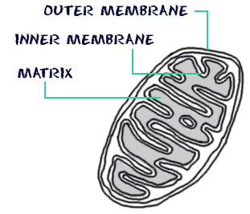
Mitochondria
Power house of the cell

Key Example:

Material Used  (Image and description) | Organelle being Represented | Definition of Organelle
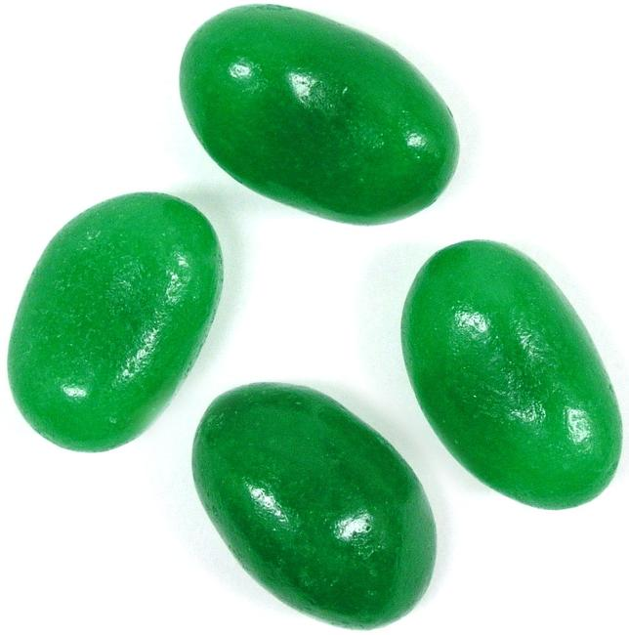  Green Jelly Bean | Chloroplast | The place in a plant cell where photosynthesis happens.

Project Examples:

